Julia's Unequivocal Nevada Klampout
#36
Whiskey Flat
clamper year 6020

Brought to you by
Julia C. Bulette chapter 1864,
E Clampus Vitus

Researched and interpreted by
Jeffrey D. Johnson XNGH,
Clamphistorian at chapter 1864

Envisioned by
Noble Grand Humbug Tim Pierce
(With Stan Paher)

Dedicated to
Francis Marion Smith for his efforts to protect and consol young, golddigging widders and old orphans but, especially the widders

2015 c.e.

Why

Tim says this was all Stanley Paher's idea. Whiskey Flat was named for an incident when some local Paiutes helping a storekeeper in Hawthorne helped themselves to a barrel of whiskey. The warriors were tracked to the flats 15 miles out where they could no longer walk. None of the contraband was recoverable and the braves worked off the debt. The Mineral County area has been hit with some rough weather this summer. Tim doesn't like his new tires getting smudged. He says watch out for Gullywashers, Clamper traps and internment camps. Arboreal features for this trip were painstakingly sought but, failed to materialize. All complaints on the subject are referred to the Clampatriarch.

Walker Lane
The Walker Lane is a major left lateral, or sinistral, strike-slip fault. The north-northwest end of the Walker Lane is between Pyramid Lake in Nevada and where the Honey Lake Fault Zone meets the transverse tectonic zone forming the southern boundary of the Modoc Plateau. (See Junk Book "Smoke Creek'' for more)The geological trough runs roughly along the Oblique line forming our border to where Death Valley intersects the Garlock Fault, The Walker Lane shares boundary motion between the Pacific Plate and the North American Plate with the San Andreas Fault. If California drops into the ocean the new seashore and plate boundary will be the Walker Lane. The eastern California shear zone is the portion of the Walker Lane that extends south from Owens Valley and continues across and south of the Garlock Fault, across the Mojave Desert to the San Andreas Fault.

Borax, Colmenite and Ulexite

Ulexite has been recognized as a valid mineral since 1840, after George Ludwig Ulex, provided the first chemical analysis of hydrated sodium calcium borate hydroxide. Colemanite (CaB₃O₄(OH)₃·H₂O) is a borate mineral found in evaporite deposits of alkaline lacustrine environments. Colemanite is formed by alteration of borax and ulexite. It was first described in 1884 for an occurrence near Furnace Creek in Death Valley and was named after William Tell Coleman (1824–1893), owner of the mine Harmony Borax Works where it was first found. Borax, also known as sodium borate, sodium tetraborate, or disodium tetraborate, is white, consisting of soft colorless crystals that dissolve easily in water. The word borax is from Arabic būraq (بورق), meaning "white. Borax was first discovered in dry lake beds in Tibet and was imported via the Silk Road to Arabia.
Back by popular demand 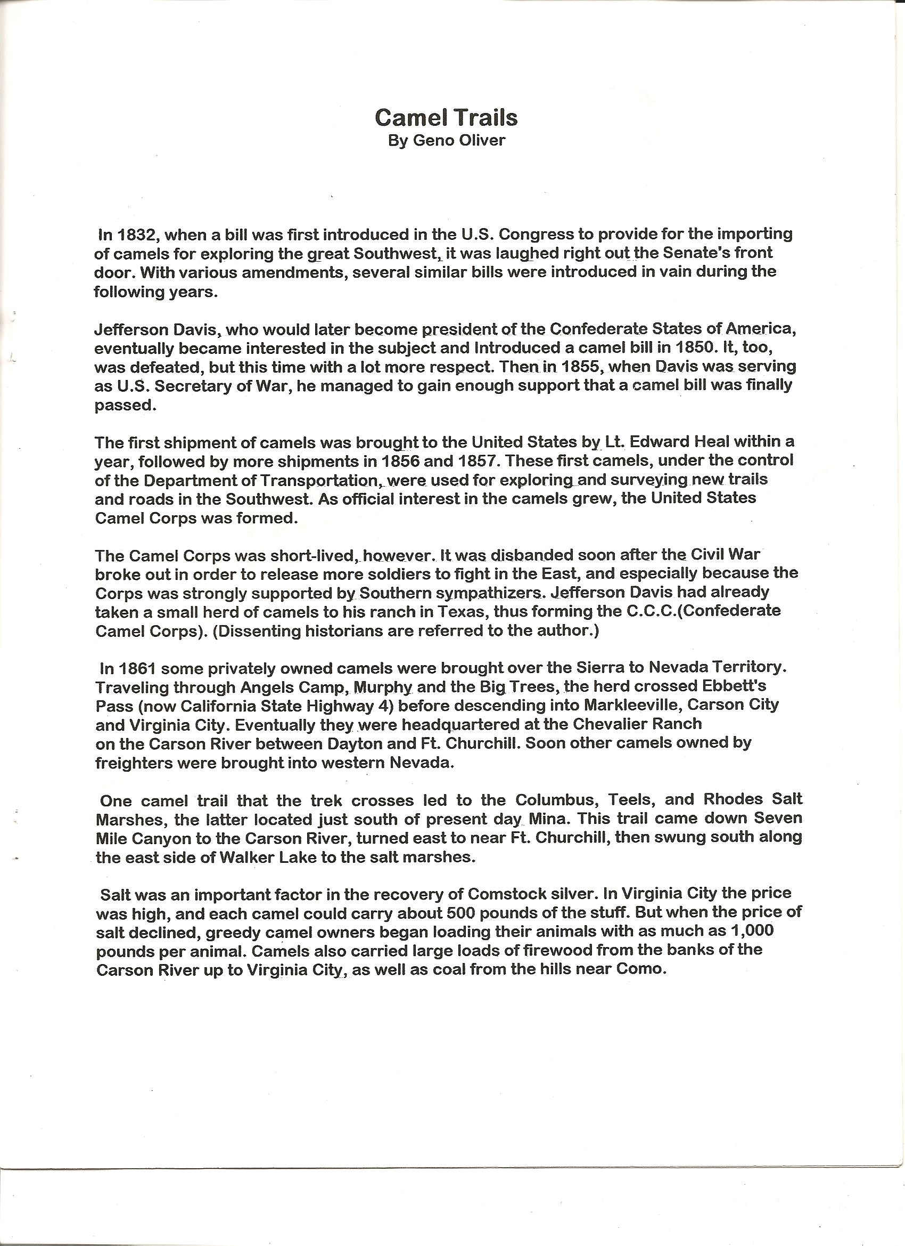

Old Man Smith
Francis Marion "Borax" Smith (1846-1931) was born in Richmond, Wisconsin and graduated from Milton College in Wisconsin. At the age of 21 he left with his brothers to prospect the west. In the late 1860's, Smith was contracting with several ore mills near Columbus Nevada as a wood butcher. While working at Teel's Marsh, he discovered a rich supply of borax. The ore assayed higher than any known sources for borax. He soon staked several claims. With the help of his older brother, Julius, and two brothers by the name of Storey, the men established a borax works at the edge of the marsh to concentrate the borax crystals and separate them from dirt and other impurities. Operations began in 1873 under the name, Smith and Storey Brothers Borax Co. Later, the Smiths acquired the Storey brothers' interest and the company name was changed to Smith Brothers Borax Co. and later to the Teel's Marsh Borax Co. The Teel's Marsh deposits soon became the world's principal source of supply and remained so for years, bringing borax to a wide commercial use around the world.
In 1875 Smith opened a retail store and office at 185 Wall Street in New York City to expand the borax market. His advertising claims that borax would “clean black cashmere, cameos and coral, keep milk and cream sweet” and "prevent diphtheria, lung fever and kidney trouble” may have been exaggerated, but they helped to popularize the cleaning additive in a prime market and in a period when sales were slumping.
In 1877, Smith founded the settlement of Marietta, Nevada, from which the borax was shipped in a 30-ton load using two large wagons with a third wagon for food and water drawn by a 24-mule team for 160 miles across the Great Basin Desert from Marietta to Wadsworth, Nevada where the nearest Central Pacific Railroad siding was.
In 1881, the new railroad provided quick and easy transportation for Smith to move to Oakland, California, where Frank began to invest in real estate, while continuing his operations at Teel's Marsh, Nevada. In 1884, Smith bought out his brother's interest in their partnership and Frank began to turn his eye to potential development in Death Valley. When William T. Coleman, who owned the Harmony and Amargosa Borax Works, the Lila C Mine, the Furnace Creek Ranch, and other properties in Death Valley, California, began to have financial troubles in the late 1880's, Smith provided Coleman with capital in exchange for mortgages on the properties in 1890. Unfortunately for Bill Coleman, his empire collapsed and Smith gained all his assets. The name of Smith's properties then became the Pacific Coast Borax Company In 1891, Stephen Mather, the administrator of the company's New York office, persuaded Smith to add the name 20 Mule Team Borax to go with the famous sketch of the mule team already on the box. In 1916 Mather was appointed the first Director of the new National Park Service.
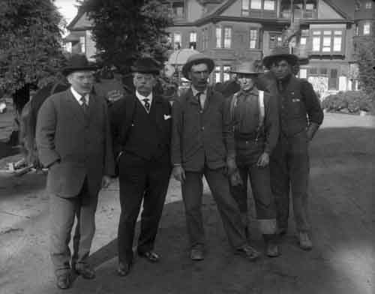

Old Man Smith with his henchmen in Piedmont Ca. in 1915 on their way with the 20 mule team to the Panama–Pacific International Exposition.

In 1905 Smith started building a railroad to his mines from the new San Pedro, Los Angeles & Salt Lake Railroad town of Las Vegas at the bidding of Senator William A. Clark. As far as turn of the century tycoons go our Mr. Smith had a beloved and generous reputation. Through his childless wife, Mollie, Mr. Smith protected and sheltered orphans in Oakland Ca. It was little consolation to him when Senator Clark, One of the worst Pricks in American History reneged and built his own Las Vegas and Tonopah RR to booming Rhyolite. Mark Twain said of Senator, Criminal Clark, " He is as rotten a human being as can be found anywhere under the flag; he is a shame to the American nation, and no one has helped to send him to the Senate who did not know that his proper place was the penitentiary, with a ball and chain on his legs. To my mind he is the most disgusting creature that the republic has produced since Tweed's time."
Borax Smith then built the Tonopah & Tidewater RR in competition with Clark's LV&T from Ludlow Ca. on the AT&SF. His was the last to the Bullfrog District but the T&T lasted longest. The T&T served the Pacific Borax mines out of Death Valley Jct. In 1902 Smith financed the development of the Key System public transportation in Oakland and the neighborhoods of the East Bay.
In 1913 Frank went bankrupt, but was saved by investments in the name of his widder in the Tonopah Extension Mining and Milling Company, which later became the West End Consolidated Mining Company. He then used his West End capital for new projects , including the acquisition of mineral rights to a large section of Searles Lake in the Searles Valley in northern San Bernardino County, California. A profitable process for refining the lake brines into marketable products was discovered and he then built the company town of Trona, California and the Trona Railway , a short-line railroad, to ship the products to the Southern Pacific Railroad connection. On August 27, 1931, Francis Marion Smith, died at age 85 surrounded by his widder and many grateful orphans.
Carson and Colorado Railroad.

The Comstock glory days were behind them in 1880. Darius O Mills, a founder of the Bank of California and chairman of the Virginia and Truckee Railroad decided to run a line south to tap into all the potential activity in places like Bodie, Aurora, and Candleria or Fort Mojave at the Southern tip of our Solid State. H. M. Yerington turned the first spade of Earth at Moundhouse in May of 1880. Hawthorne was secretly located at the South end of Walker Lake where investors who owned teamster outfits could access the line. Lots were sold when the C&C reached the secret spot in April 1881. The C&C RR made it as far as Keeler at Owen's Lake in California. In 1883 on a tour of his new train set Darius O. Mills said, "We either built this thing 300 miles too long or 300 years too soon. When the Southern Pacific purchased the C&C in 1900, they abandoned Hawthorne during the gauge change in 1905. In 1931 the Government built a connecting railroad to serve the huge Ammo base. The Southern Pacific abandoned the track south of Mina in 1949 and (railroad direction) East of Thorne in 1986

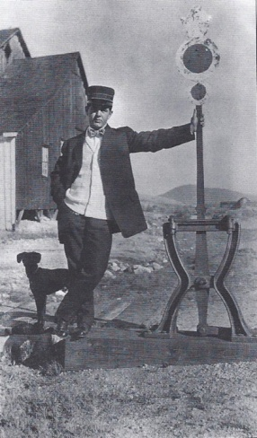
Brakeman at the switch in Moundhouse

Sodaville
Soda Springs was famous for it's springs, One hot one cold. It was good water for the locomotives of the Carson & Colorado railroad and was renamed Sodaville. Starting December 1881, this town became the end terminal and shipping point for the mines in the area. In 1904, when the Tonopah Railroad opened its own rail service, the SP RR, owners of the C&C, wanted to make the junction at Sodaville. A Wylie entrepreneur leased up all the land surrounding Sodaville and tried to play hard ball with SP Chairman E. H. Harriman. The SP RR then just piped in some good water out of the Excelsior Mountains into Mina and built a large yard, visible today. In 1905, the town of Sodaville evaporated and the Tonopah RR added Goldfield to it's name.

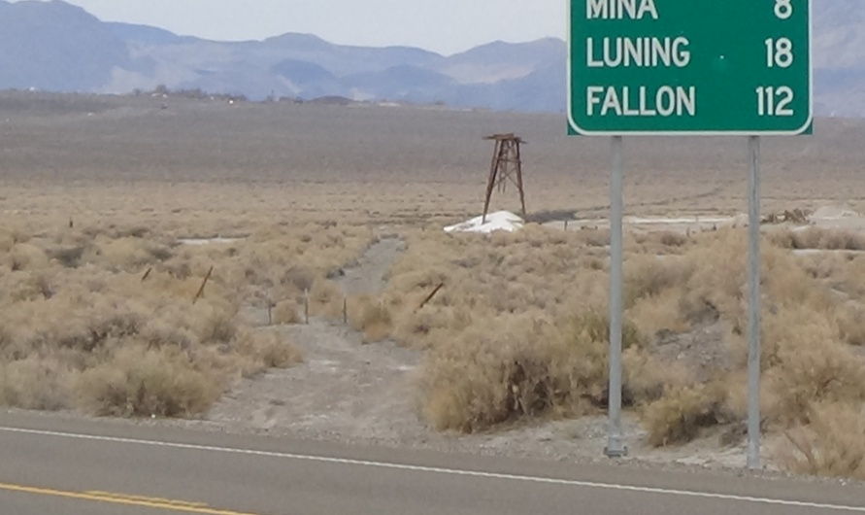
Sodaville from Rhodes with C&C mainline

Rhodes
Rhodes was founded near the salt marsh in 1862. The salt was shipped from Rhodes to Virginia City via camels for use in the mills. However, a closer source of salt was located in Sand Springs in 1863 and business slowed. Rhodes still supplied salt for the mills of Aurora, Belmont, and Belleville. Just south of the Highway Jct, US 95 and Nv 360, is the location of Tonopah Jct. where the Tonopah and Goldfield Railroad split from the C&C. During the rush to Tonopah and Goldfield a monstrous jam of supplies and equipment piled up first at Moundhouse and then Sodaville. The Carson and Colorado RR was a narrow guage outfit and the freight needed to be transloaded. The V&T was uncooperative, they had just sold the C&C to the SP before the boom. So Chairman Harriman built a direct line from Hazen to Churchill and ran around the V&T altogether. As fast as they could accomplish it the SP standard gauged the track to Tonopah Jct. and the new Tonopah RR was standard gauged too. The rest of the old C&C to Owens Lake was left gauge was left at 3 feet. From Tonopah Jct to Mina there was three rails to accommodate both gauges to Mina. Even the yard had three railed tracks. The C&C from Tonopah Jct to Keeler was the last narrow gauge property of the Southern Pacific.
Today, all that remains of Rhodes is the salt loading tower

Belleville
In 1873, the Northern Belle Mine Company of Candelaria built a 20-stamp silver mill at this location. By 1876, another 20-stamp mill had been built above Belleville. When the C&C reached the town in 1882 its population was 500, and the town was served by a doctor, assay office, express office, telegraph station, livery stable, school, two hotels, restaurants, and blacksmith shops as well as by seven saloons. All of these businesses made their money off the miners working in Candelaria. In 1892, the Northern Belle Mine Company built a pipeline to Candelaria from the White Mountains so it could build a mill closer to the mines. Belleville disappeared. Today you can still see the large mill foundations, several cellars, old residences, and a few graves.
Candeleria

Candelaria is dominated by the Kinross Gold Candelaria Mine on Mt. Diablo. The area first attracted notice in 1863 when Mexican prospectors working the area near Mt. Diablo discovered silver deposits on the northern slopes of the mountain. Candelaria wasn’t truly a town, or even a camp, until 1879 and soon became a boomtown. There was insufficient water locally for the use of milling and processing the ore from the mines. The stamp mill in Candelaria had to operate as a dry mill, which spread toxic dust throughout the area. Unlike other camps where a wet milling process was used, Candelaria miners suffered from an extremely high incidence of “miners consumption”. The completion of a spur of the Carson and Colorado Railroad to Candelaria in 1882 helped to ease the water problems, as large tanks of water moved by flatcar could now be brought to the town. With the mine producing an average of one million dollars a year, the mining company started paying its stockholders dividends. $15 million in silver from its shafts brought to the town two hotels, numerous stores, the ever-present saloons, three doctors (no doubt kept busy treating lung ailments), and lawyers and other professionals. By 1883, the town had a bank, telegraph, school, and newspaper. In 1883, a fire, fed by the constant wind, consumed Candelaria. Due to legal difficulties the following year, the Northern Belle mines and the Holmes mines merged. In 1885, a summer-long strike by miners resulted in another slow year of production.
In 1893 a financial panic dried up capital and development of the mines ceased, and as a result many of them closed. Soon the town was drained of people, as they moved on to other areas where work could be found, and under more hospitable conditions. Even in its best days, though, Candelaria was a terrible place to live.
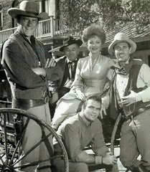
Our Clampatriarch when in the custody of the Marshall of Dodge City, Kansas
Equus caballus
Feral horses in the Garfield Flat Herd Management Area in western Nevada exist as 2 subpopulations most of the year and as a single population once sufficient snow has accumulated to free them from dependence on their respective water sources. The harem band, consisting of ≥1 females, their offspring, and generally 1 but occasionally up to 3 adult stallions, is the basic reproductive unit for feral horses. Harem stallions vigorously defend their band from takeover or theft of mares by outside males and guard against females straying from the harem.. Therefore, adult membership of harem bands can remain constant for several years. Offspring of both sexes remain in their natal band until sexual maturity, generally age 2 or 3, and then disperse. Dispersing females either join an existing harem band or are picked up by a bachelor to form a new harem. Dispersing males can join a bachelor band, remain alone, or join a harem band as a subordinate male. Males can acquire a harem by capturing a dispersing female, stealing a female from another harem, or by ousting the dominant male of a harem (through combat). Feral horses generally are nonterritorial and bands can have widely overlapping home ranges that can be fairly constant from year to year. Bands of feral horses, harem and bachelor alike, occasionally will aggregate, forming loosely spaced associations.
Feral horses typically produce 1 foal/season after a gestation period of approximately 11.5 months If a mare becomes pregnant postfoaling, it is most likely to occur during the 1st postpartum estrus, or foal heat, that begins 7–10 days after delivery. Although horses are capable of foaling at any time of the year most feral horses foal in the spring and summer. Females are most likely to mate with a male resident of the harem band, with dominant males gaining the highest success rates Within multi-male bands, subordinate males have lower mating rates. Females that mate outside their harem band can reproduce with dominant, subdominant, or bachelor males. At Garfield Flat, paternity analysis showed that such females were more likely to mate with a male from another harem band than with a bachelor. The potential for gene flow between sub-populations exists when the groups are in contact during the foaling season. Gene flow can be affected by the number of females that come into foal heat during the overlap period, effectiveness of harem defense by males, and degree of extra-band copulation between populations. If a member of this commitee is thirsting on the desert range and he comes upon his neighbors Mare, he is very likely to Mount it, Knowing full well it does not belong to him. Note to the wise.

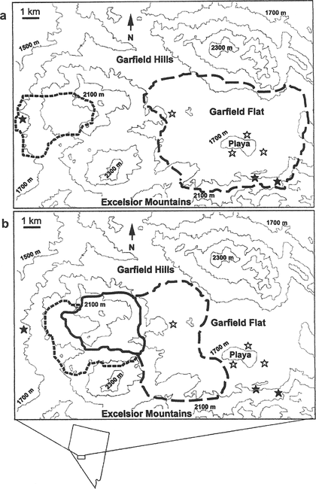
A Proctor, a Humbug, a Clampatriarch and a dead salmon meet at the bar........

Marrietta

Marietta was founded by Borax Smith at Teels Marsh to house his Pacific Borax workers. The area had been periodically mined for salt, which was used in the processing of ore in the Virginia City, Aurora, NV, and Bodie, CA mills. The use of camels to transport salt to Virginia City has often been rumored.
Marietta was formally established as a town in 1877. The town boasted 13 saloons, a post office, several stores and many stone and adobe structures. Borax Smith preferred Chinamen for his scraping crews. Marietta was a rowdy camp and seemed to garner more than its fair share of criminal activity. The stage service working to and from Marietta was reportedly robbed 30 times in 1880, within one week of that year alone it was robbed 4 times.
Despite the crime, scraping the marsh and processing the borax and salt was very lucrative, as was some small amount of gold and silver mining nearby. For the better part of 20 years Marietta soldiered on. Starting in the early 1890's, the supply for borax and salt had expanded from central Nevada to deposits in southern California. The Pacific Borax Company still owns the eastern claims on the marsh.
Since 1991 the area is a federally (BLM) managed Wild Burro Range. This 68,000-acre (280 km²) range, which includes the site of Marietta and Teels Marsh, is home to about 85 burros. Small groups of the burros can often be found roaming among the ruins of Marietta.

Teel's Marsh

Dajin is an early stage energy metals exploration company holding a 100% interest in claims known to contain lithium and boron values in the Teels Marsh region of Mineral County, Nevada which cover 5,405 acres. Work by the US Geological Survey identified the presence of lithium concentrations. The US Federal Government recently granted funding of over $28 million to assist in the expansion of this production. Tesla Motors Inc. is constructing a "Gigafactory" battery manufacturing facility for the production of lithium ion batteries east of Reno, Nevada. These batteries are being produced for the automotive markets.
Active tectonics have, over time, created a deep, closed basin that has trapped ground water within the sedimentary fill rich in volcanic sediments. Trapped ground water has circulated for millennia in a climate where evaporation was greater than precipitation. This strongly evaporitic climate lead to the increasing enrichment of the basin's ground water with soluble salts of lithium and boron that were probably leached from volcanic ash that was generated by large eruptions to the west including the Mono Lake Craters and the Aurora Crater eruptions. In episodes of rain and snowfall in which none of the waters enters the phreatic zone, ions in the rain and snow accumulate near the ground surface. This accumulation of material, together with the sparse rain and snowfall, inhibits chemical weathering of silicate minerals. Halite (sodium chloride), and ulexite (a calcium sodium borate) were mined in the valley from 1860 till 1892. US Borax still holds the private ground in the east of the playa.
U.S.G.S. studies found Teel's Marsh to have the highest consentrations of Lithium in the United States. The highest lithium assay value was 850 ppm. Teels Marsh is also a known geothermal site. Just as with circulating basin waters, the hot ones associated with the geothermal resource, dissolve rocks, liberating boron, lithium and other elements such as sodium and chloride. These minerals are brought to the surface as springs emanating from the faults bounding the playa.

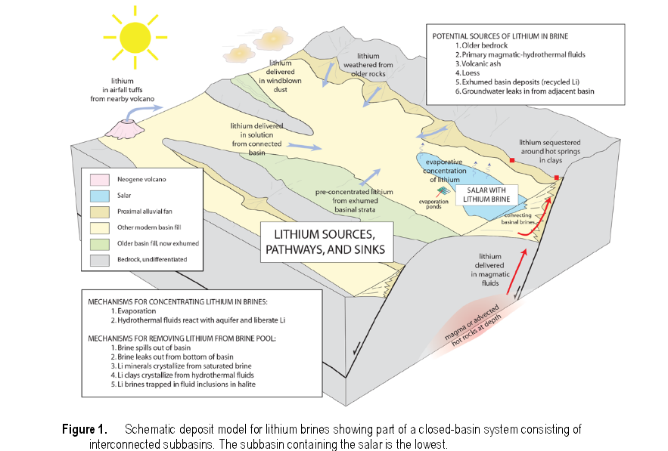

Excelsior mts
Rb-Sr isochrons obtained for locally extruded siliceous volcanic rocks in units in the Excelsior Mountains indicate ages 103 ± 5.7 m.y. Plutonism occurred mainly between about 70 and 100 m.y. The newly dated volcanic rocks of the Excelsior Mountains provide the first recognition of a volcanic center of Cretaceous age in the Great Basin and evidence that at least some of the thrusting and folding in the Excelsior Mountains region occurred in the Cretaceous or later time. Together, the two new ages indicate a more prolonged history of Mesozoic sedimentation and extrusion than previously realized. The dated volcanic rocks of the Excelsior Mountains are generally contemporaneous with recently discovered Cretaceous extrusive rocks in the central Sierra Nevada, suggesting that volcanism may have been widespread in the Cretaceous.

Mineral County
Mineral County attained regional prominence in 1860 when gold was discovered in Aurora, subsequently leading to formation of the Esmeralda Mining District. The district was immediately claimed by both California and the Territory of Utah, prior to the establishment of Nevada Territory. California created the new County of Mono because it believed the discovery site was within that State. Esmeralda County was an original 1861 Nevada Territorial County with the county seat in Aurora till 1883. In 1864 Nye County was carved away by the State Legislature. From 1883 till 1907 the seat was in Hawthorne. In 1907, Goldfield was the most populous Nevada town and requisitioned the county seat. In 1911 Hawthorne successfully petitioned the legislature for it's own County, Mineral.

Burros
The Marietta Wild Burro Range was publicly dedicated in 1991, the 20th anniversary of the passage of the Wild Free-Roaming Horses and Burros Act. The 68,000-acre range is managed for between 78-104 wild burros (Equus asinus asinus). The burros roam freely near the ruins of the historic Nevada mining town of Marietta and the seasonally changing Teels Marsh. Patented mining claims around the Marsh and the Marietta mining district account for 1,500 acres of private lands within the area. One reason for this area's designation as a range is the unique opportunity available for public viewing of the herd and its habitat.
Congress said "...wild free-roaming horses and burros contribute to the diversity of life forms within the Nation and enrich the lives of the American people." The Marietta Wild Burro Range is one of about 15 areas where burros can be found in Nevada. As of August 2011, there were approximately 38,500 wild horses (Equus caballas) and burros on BLM-managed lands. A majority of these animals reside in Nevada and are managed by the BLM.
Wild burros evolved in the deserts of northern Africa and parts of Asia. They adapted to hot, dry summers, cold winters and marginal food sources. These traits combined with physical strength made the burro a useful pack animal. Early explorers brought both horses and burros to the New World. Today's populations reflect Nubian and Somalian characteristics. The Nubian is the most dominant subspecies. It has a black stripe across the shoulders and one that extends down the middle of the back. The Somalian has stripes on both the front and back legs resembling a zebra. Hair color varies from a bluish tint to shades of gray. Combinations of white, black and brown are common. During the late 1800s, miners used burros as pack animals while prospecting for gold and silver in the Marietta Mining District. The Marietta herd is unique in Nevada, since this is one of the most northern burro populations of any size. The animals themselves are larger than those encountered in areas to the south.
Vegetation throughout the range includes various grasses, brush and trees. The burro prefers Indian ricegrass and four-wing saltbush, but will eat whatever it can to survive. Even though this area is a desert, there are several springs within the range where the burros seek water. The most used springs are on the west edge of Teels Marsh. During the hot summer months, the burros are usually within two miles of water, especially females with young foals. As fall approaches, the burros disperse and are found at the higher elevations and up to six miles from water. Wild burros have been known to walk 15 miles without water and then drink five gallons in two and a half minutes, a capability surpassed only by the camel. Burros grow to be about half the size of a horse and weigh between 400 and 600 pounds. Males are called jacks, and females are called jennies.
Garfield Flat

East of the petroglyphs and west of Mina is Garfield Flat. The paranoid and guilt ridden may have reason to believe this is a Fema camp ready to fill with discontented workers, but no. Garfield Flat was once used for bombing practice and jet R&D. This property is owned by AeroJet out of Rancho Cordoba. The Nevada-Florida Land Exchange Authorization Act, was signed on March 31, 1988. Two existing wildlife refuges in Florida were expanded, and as always, the fictitious ''new job opportunities'' were to be provided in Nevada. Aerojet owned land in Florida that the South Florida Water Management District (SFWMD) wanted to acquire for water conservation purposes. Aerojet wanted two parcels of land in Nevada, one in Coyote Springs Valley for construction of a rocket motor assembly plant and one at Garfield Flat to be used as a buffer zone around its existing munitions testing range. The Aerojet General Corporation has utilized the Garfield Flat Test Site to conduct research, development, and production testing on various munitions systems for the Department of Defense since 1967. The fence is to keep Feral Horses and thrill seekers from discovering undetonated ordinance on the playa.

PETROGLYPHS

The valleys surrounding the Excelsior Mountains are the Winter range of the Mule Deer population that summer in the High Sierra. Since ancient times the local hunter gatherers have built blinds, walls and tagged the basalts and tufas with Curvilinear scribblings. Many petroglyph sites mark the entrances to canyons and routes between forage and water. Some petroglyphs record plasma discharges that were once seen over the earth's atmosphere long ago. Some mark celestial events and some are said to have been made by early explorers from before the time of Columbus.

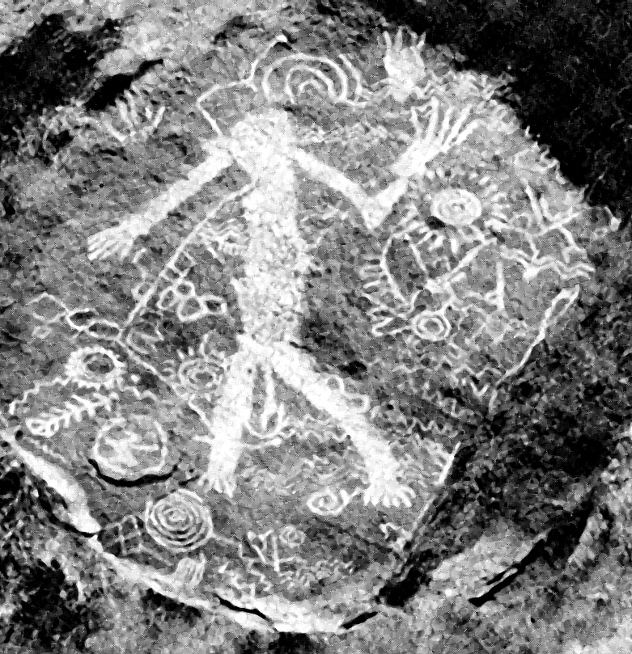

Bibliography
Geograghical Memoir for the Senate, J. C. Fremont 1848
http://www.blm.gov/style/medialib/blm/nv/field_offices/carson_city_field/archaeological_resources.Par.74785.File.dat/SilverBoraxFinal.pdf
http://www.equities.com/news/issuer-updates/dajin-ships-samples-for-lithium-assay-from-teels-marsh#sthash.wSqzX3fn.dpuf
http://www.geology.cwu.edu/facstaff/lee/publications/pdf.papers/GSAPenrose.06.pdf
https://books.google.com/books?id=bSnnAAAAMAAJ&pg=PA4&lpg=PA4&dq=teels+marsh+borax&source=bl&ots=RgINRx1ShX&sig=2XWEcwAotO5MO61jqjXTJf98wSE&hl=en&sa=X&ved=0CDsQ6AEwBWoVChMItY7kre_lxgIVjy-ICh1ywAl6#v=onepage&q=teels%20marsh%20borax&f=false
187o Marsh Borax discovered
http://www.dezertmagazine.com/mine/1957DM03/index.html
http://www.fourwheeler.com/features/0306-4wd-ghost-towns-nevada-ghost-towns/#ixzz3hxdmjH3u
https://books.google.com/books?id=Bmc1AAAAIAAJ&pg=RA2-PA154&lpg=RA2-PA154&dq=Excelsior+mts&source=bl&ots=Ml96qOIVVH&sig=AUe1tGXsL5NQDMbCMlT5Jiy3n6A&hl=en&sa=X&ved=0CCUQ6AEwAjgKahUKEwjw0YPh_OXGAhXNWogKHbs6Chk#v=onepage&q=Excelsior%20mts&f=false composed of Triassic sediments ranging from fine grained argilites intrusions of Cretaceus Quartz and capped by Tertiary andesite and basalt
http://www.dot.ca.gov/hq/row/landsurveys/Study_material/State_Boundaries/ca-nv-border-p1-2.pdf
http://www.blm.gov/nv/st/en/fo/carson_city_field/blm_programs/recreation/marietta.html
Nevada: The Narrative of the Conquest of a Frontier Land (1935) James G. Scrugham
http://dajin.ca/teels-marsh/
Thompson & West's History of Nevada 1881.
Petroglyphs of Nevada and Eastern California, Hiezer and Baumhoff
Railroads of Nevada and Eastern Nevada Vol 1&2, D Myrick 1962.
Burning Daylight is a novel by Jack London, published in 1910,
http://www.blm.gov/nv/st/en/fo/carson_city_field/blm_programs/recreation/marietta.html
Nevada History, John Evanoff 2007
Nevada History, Chapter LVIII Washoe County, Major G. W. Ingalls
Hildebrand, GH. (1982) Borax Pioneer: Francis Marion Smith. San Diego: Howell-North Books. ISBN 0-8310-7148-6
http://www.blm.gov/nv/st/en/fo/carson_city_field/blm_programs/recreation/marietta.html
http://www.nbmg.unr.edu/Staff/Faulds/33_AGS22_Faulds_and_Henry_(Walker_Lane)_final.pdf
https://books.google.com/books?id=bSnnAAAAMAAJ&pg=PA4&lpg=PA4&dq=teels+marsh+borax&source=bl&ots=RgINRx1ShX&sig=2XWEcwAotO5MO61jqjXTJf98wSE&hl=en&sa=X&ved=0CDsQ6AEwBWoVChMItY7kre_lxgIVjy-ICh1ywAl6#v=onepage&q=teels%20marsh%20borax&f=false
187o Marsh Borax discovered
Stanley W. Paher (1999) The Nevada Ghost Towns and Mining Camps Illustrated Atlas, Volume 1: Northern Nevada: Reno, Austin, Ely and Points North
Nevada Conifers, D. A Charlet 1996
http://www.NevadaObserver.com/archives
https://en.wikipedia.org/wiki/Ulexite

Blasts in the Past

1980 GENO OLIVER, STAR CITY-UNIONVILLE
1981 SKIP PENNINGTON+, MANHATTEN
1982 BILL KENNEDY, KENNEDY
1983 JIM CRONN+, PINEGROVE
1984 GEORGE COURSON, LEADVILLE
1985 DOUG WALLING, BERLIN
1986 DAVID WOOD, ROCHESTER
1987 JOE LEPORI, AURORA
1988 BILL SAWYER+, SULPHUR
1989 MIKE MILLER, MILLER’S STATION
1990 RED BEACH+, SHAMROCK
1991 BOB RODGERS, COMO
1992 RON WALSH, SEVEN TROUGHS
1993 DANNY COSTELLO, THE REAL NATIONAL
1994 JIM GROWS+, DESERT WELLS
1995 DANIEL BOWERS, HIGH ROCK CANYON 1996 PETER VAN ALSTYNE+, FAIRVIEW
1997 EDDY GONZALES, GRANTSVILLE 1998 JOHN DORNSTAUDER, HUMBOLDT CITY
1999 KEN MOSER, BELMONT
2000 VAL COLLIER+, PEPPER SPRINGS
2001 CHUCK MURRAY, NIGHTENGALE
2002 MARC BEBOUT, NEW PASS MINE
2003 AL NICHOLSON, lONE
2004 RON THORNTON, FLETCHER STATION
2005 J D PATERSON, APPLEGATE-LASSEN TRAIL
2006 WALT SIMMEROTH, NEVADA CENTRAL R. W.
2007 JEFF JOHNSON, ADELAIDE
2008 OWEN RICHIE+, TYBO
2009 KARL SMALL, DUN GLEN 2010 DAN WESTON, KINGSTON
2011 RUSS BREAM, SMOKE CREEK 2012 JESS DAVIS, FREMONT'S CASTLE
2013 CLIFF McCAIN, KNOTT CREEK
2014 BOB STRANSKY, JARBIDGE
2015 TIM PIERCE, WHISKEY FLAT
.“Gone to Silver Hills + ''

